**LETSUPGRADE CYBER SECURITY ASSISGNMENT**

**DAY 4 (23 Aug 20)**

**Q 1 .Find out the Mail Servers of the following Domain:**

1. IBM.COM 2.WIPRO.COM

**Solution:**

Using nslookup we find the Mail Server of any Domain.

Ibm.com – **Two** Mail Servers

Wipro.com – **One** Mail Servers

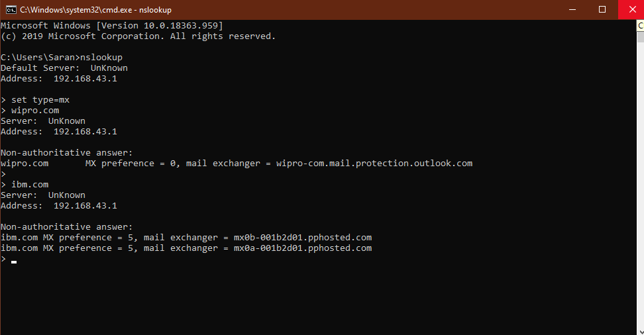

**Q 2 .Find the locations, where these Email Servers are Hosted:**

**Solution:**

~ **Wipro** has 1 Mail Server – wipro.com.mail.protection.outlokk.com

**Location:** Singapore

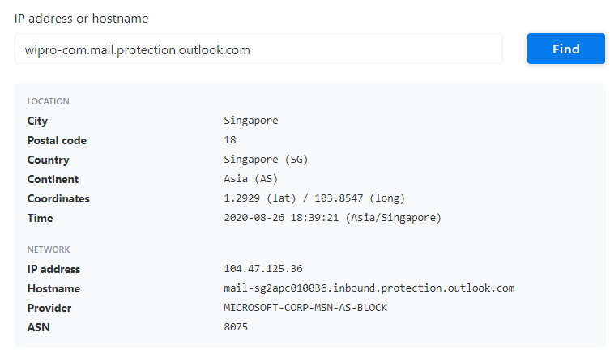

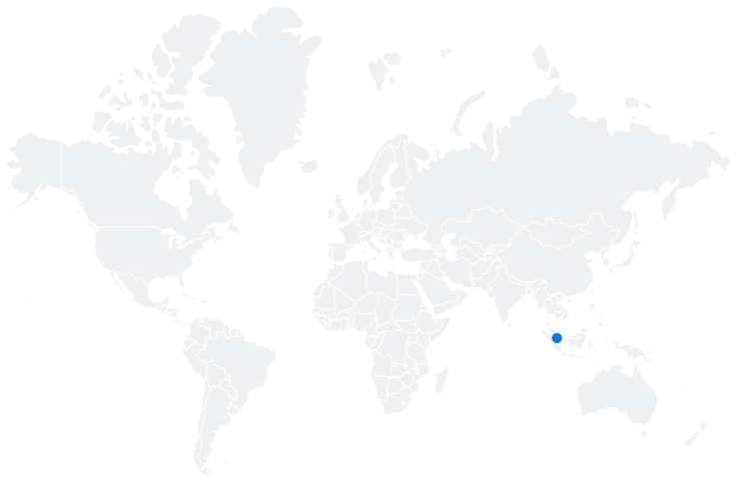

~ **IBM** has 2 Mail Server - 1. mx0a-001b2d01.pphosted.com

**Location:** United States

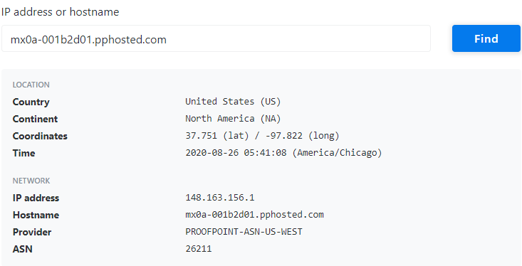

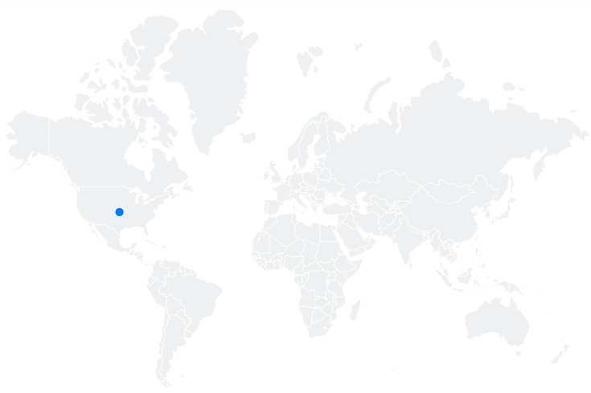

2. mx0a-001b2d01.pphosted.com **Location:** United States

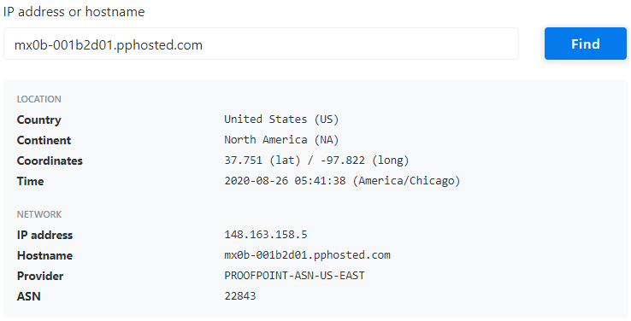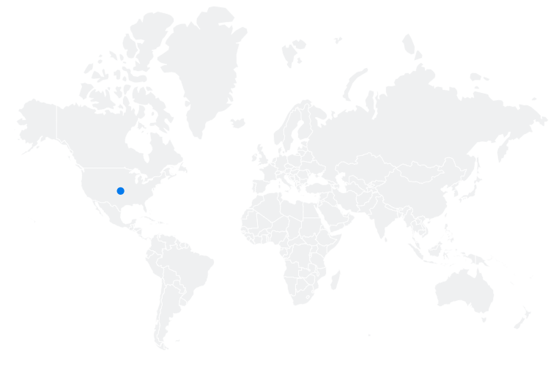

**Q 3 .Scan and Find out Port Numbers Open 203.163.246.23**

**Solution:**

Using NMAP we find the Port Numbers Open.

For the IP address **203.163.246.23 there** is no open ports

(Note: Host Seems Down)

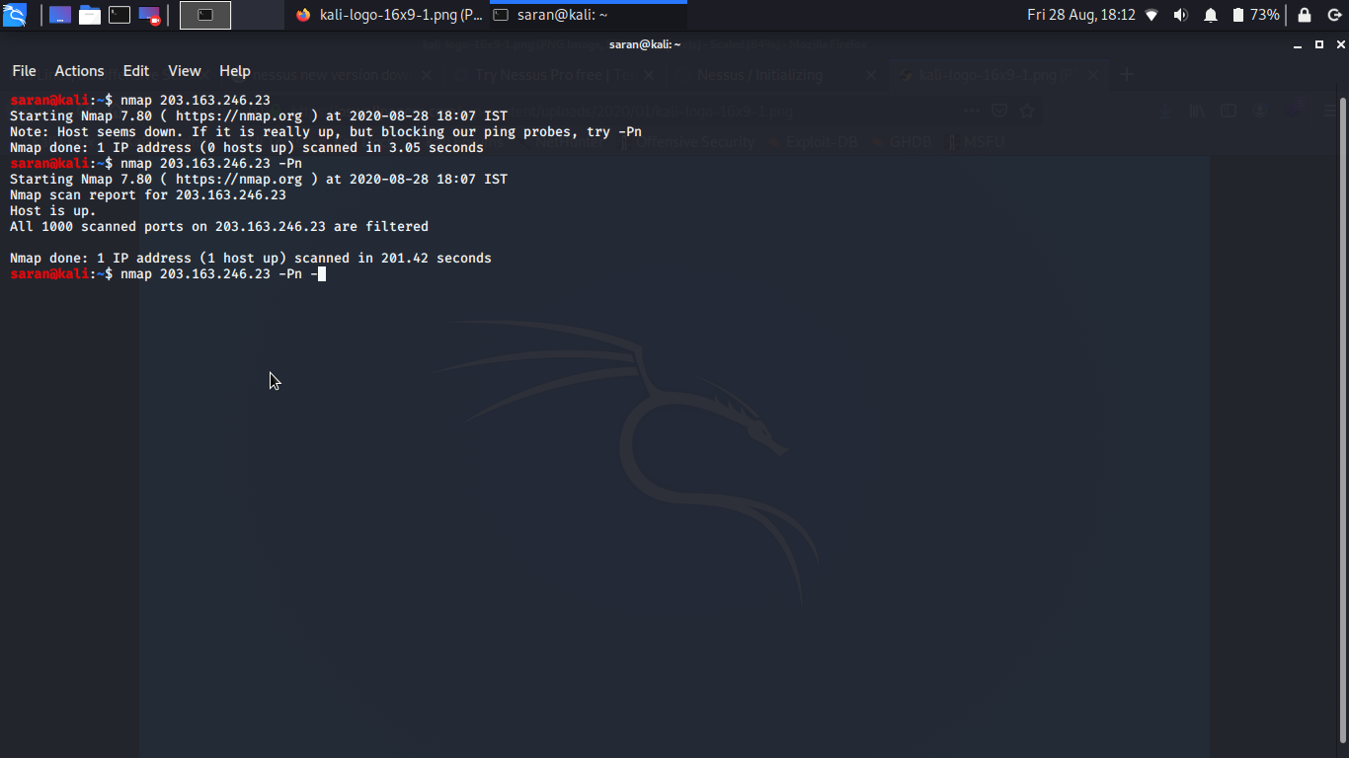

Some Others Details of the this IP Address:

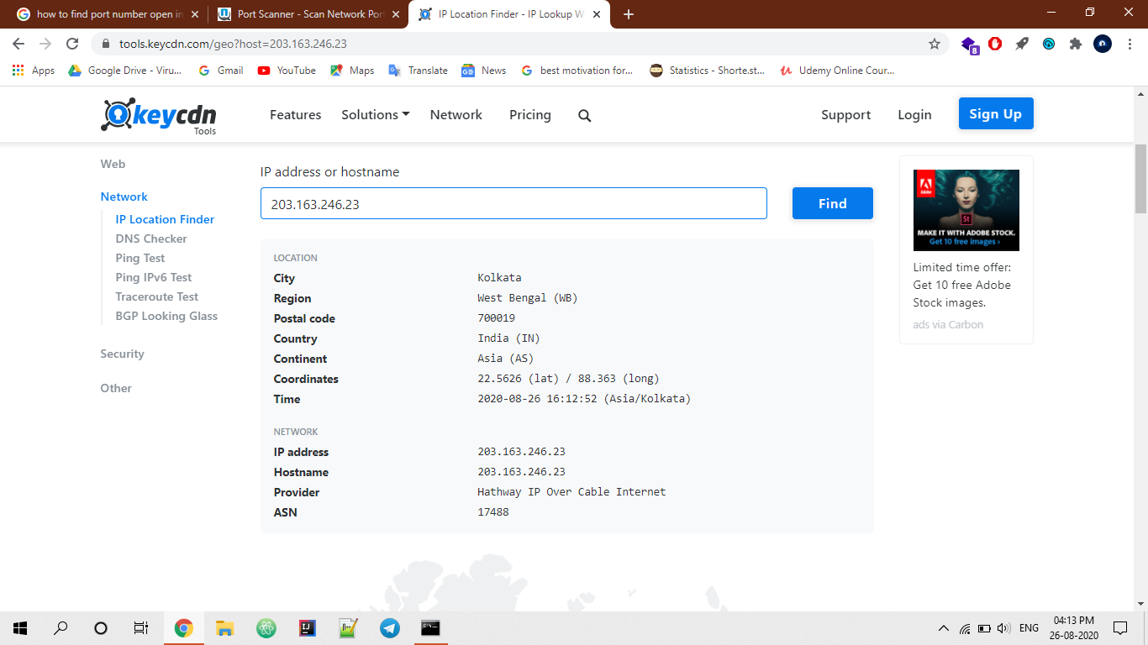

**Q 4. Install Nessus in a VM and Scan your Laptop for CVE.**

**Solution:**

**Nessus** is a Remote Security Scanning Tool, which raises an alert if it discovers any Vulnerabilities..

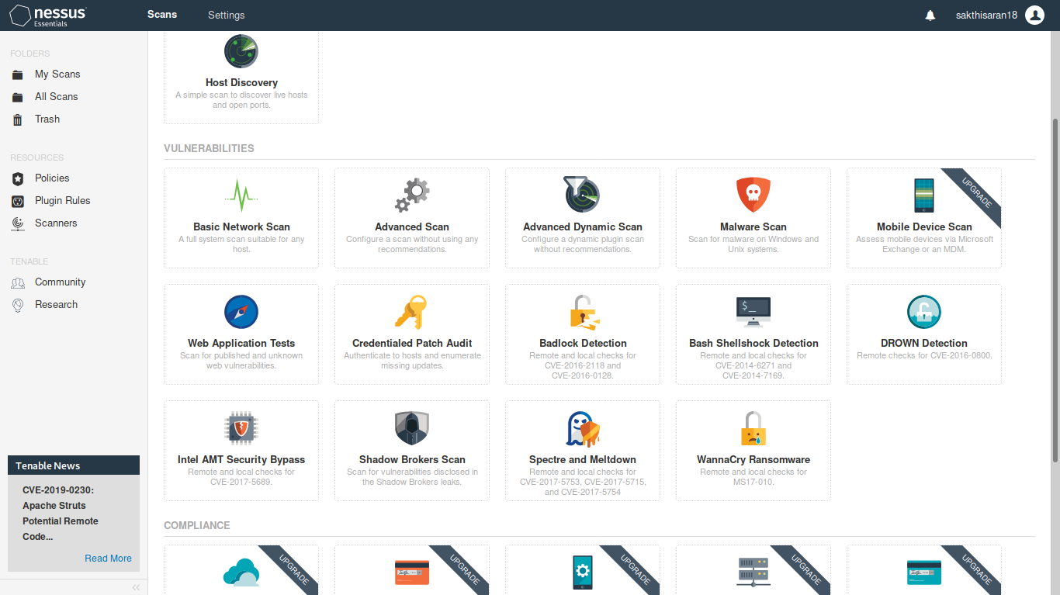

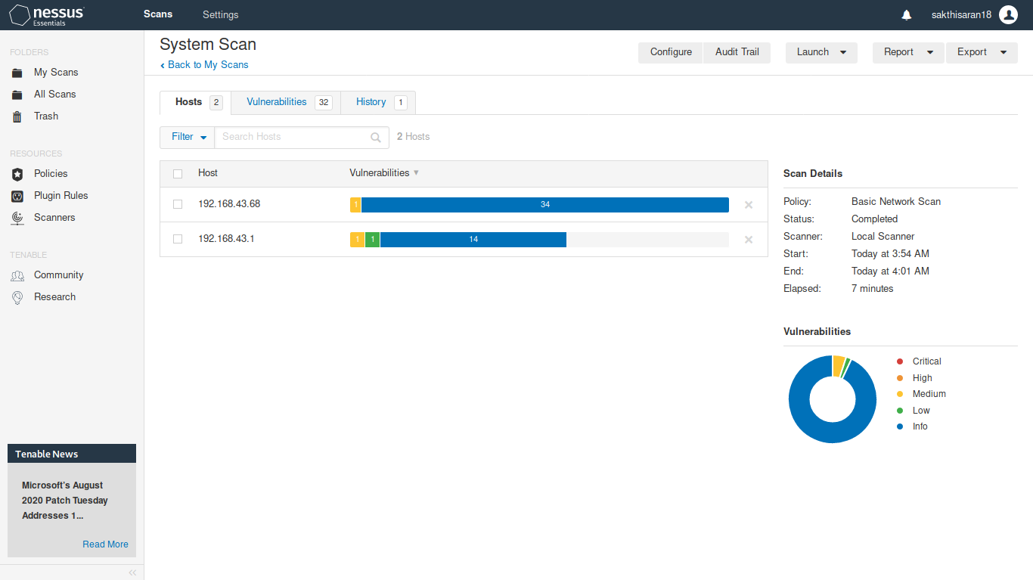

Some Images of

Scanned Report

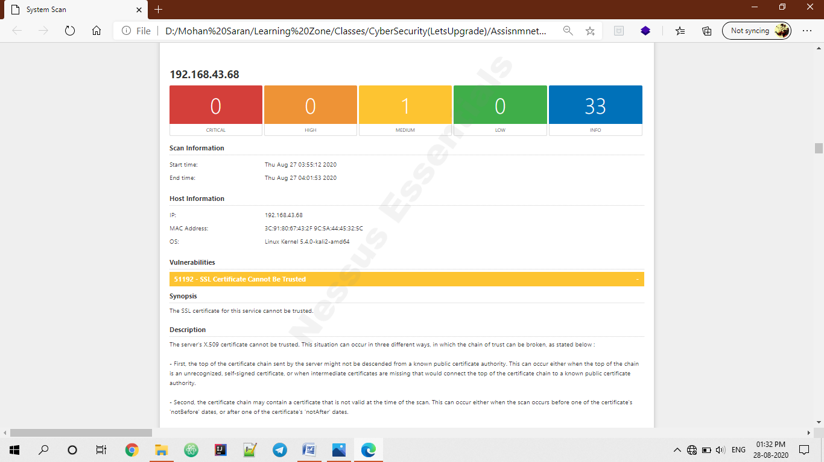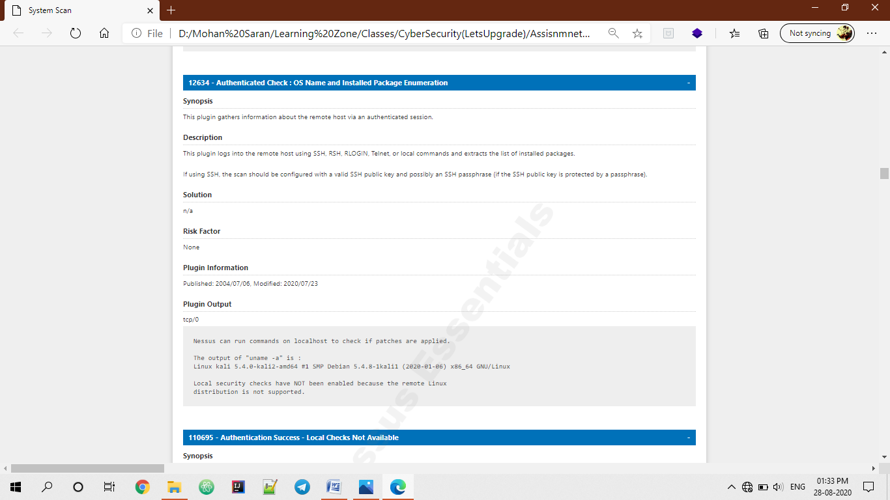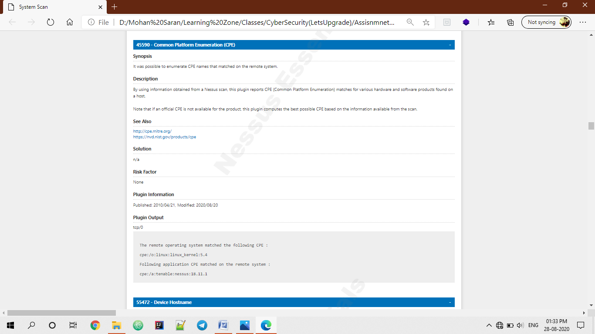

**BY,**

**M.SARAN**

**(mohansaran18@gmail.com)**